A Patient’s Guide Through Breast Reconstruction

Table of Contents
Breast Reconstruction at Finesse Plastic Surgery 1
Breast Cancer Treatment Options: 2
Reconstruction Options After Lumpectomy: 2
1. Elect not to have reconstruction. 2
2. Oncoplastic Breast Reduction. 2
3. Oncoplastic Breast Lift. 3
4. Fat Grafting 3
Reconstructive Options After Mastectomy 4
1. Elect not to have reconstruction. 4
2. Two-Stage Implant Reconstruction 4
3. Direct-to-Implant reconstruction 6
4. Autologous breast reconstruction/flap surgery 6
A. The back – Latissimus Flap 6
B. The Abdomen –TRAM Flap 7
C. The Abdomen – DIEP Flap 7
D. The Buttocks: SGAP/IGAP flaps 8
E. Fat Grafting 8
Nipple and areola reconstruction 8
Revision of Reconstruction 8
Frequently Asked Questions 9
How long will I be in the hospital? 9
What problems should I watch for after surgery? 9
Medications 9
What should I expect as far as pain after surgery? 9
What about constipation caused by the pain medications? 10
When should I start the antibiotics and how long do I keep taking them? 10
What is the downtime after surgery? 10
Do I need a special bra after surgery? 10
When will the drains be removed? 10
How long do I need to use the DVT prophylaxis cuffs? 11
How often will I need to come in to the office after surgery? 11
Can I shower after surgery? 11
When can I take a bath or go swimming? 11
What are my limitations after surgery? 11
What kind of exercise can I do after surgery? 11
When can I start driving? 12
When can I start taking ibuprofen, asprin, vitamins, and/or fish oil? 12
EXPANSIONS 12
When will the expansions start, and how often is it done? 12
How does expansion work? 12
Are the expansions painful? 12
How many expansions will I need? How will I know when I’m done? 12
Will the surgery delay my chemotherapy? 13
When will I start radiation therapy? 13
Next Surgey 13
What should I expect as far as the next surgery? 13
How long do breast implants last: 13
What are the different implant choices? 13
Is silicone safe? 14

Breast Reconstruction at Finesse Plastic Surgery
Nothing prepares you to hear that you have breast cancer, or that your genetic profile significantly increases your risk of developing breast cancer. This is a challenge that 1 in 8 women will face during their lifetime. Treatment options can include surgery, radiation, and medical therapies. We aim to empower our patients to be a part of the decision-making process, especially when it comes to breast reconstruction options. The purpose of this guide is to summarize the different types of breast reconstruction procedures, discuss their pros and cons, and answer the most common questions that patients ask us.
We have the ability to rebuild and reshape your breasts with the most modern reconstruction techniques using implants or your own tissue (flaps). Many patients elect to begin their reconstruction the same day as their cancer treatment, while others choose to delay this step or not proceed with reconstruction at all. We will take time to discuss your goals and develop a personalized treatment plan that helps you achieve them.
At Finesse Plastic Surgery our commitment to you is to give you the best results possible, so that you can feel whole, feminine and confident.
Your Finesse Plastic Surgeons:
JustinWest, MD
Mark Gaon, MD

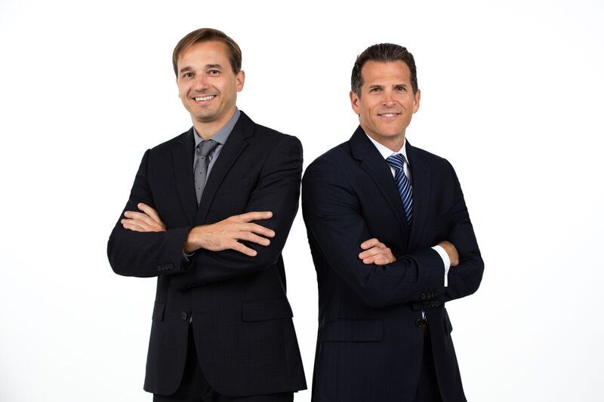

Breast Cancer Treatment Options:
Prior to meeting with a plastic surgeon, most patients have either met with a breast surgeon or medical oncologist. Many will already know if they are a candidate for a breast conserving surgery or if a mastectomy has been recommended by their breast cancer team. The next few pages will describe and outline all reconstruction options.

Reconstruction Options After Lumpectomy:
Nearly half of all patients diagnosed with breast cancer undergo lumpectomy (partial mastectomy). The goal of this procedure is to remove the cancer while preserving a natural breast shape. The aesthetic result that a patient obtains following lumpectomy surgery is based on a number of factors including the size of the breast, the size of the cancer, and the location of the cancer within the breast. There are several reconstructive options available to patients who plan to undergo a lumpectomy. These procedures may be performed the same day as the cancer surgery, or maybe delayed to another time. Timing for the surgery, chemotherapy, and radiation must be considered on a case-by-case basis.

1. Elect not to have reconstruction.
Many patients are able to have their cancer removed and achieve an excellent aesthetic outcome without having any form of reconstruction. However, this is not always the case. Studies have shown that up to 30% of patients who have a lumpectomy are unhappy with their aesthetic outcome. One common concern patients have following this procedure is differences in breast size. Patients also frequently notice a contour depression in the area where the cancer was removed. We frequently help these patients to improve their results following lumpectomy and radiation using a variety of reconstruction techniques. However, it is easier to prevent the contour problems seen after lumpectomy than to fix them. By offering a consultation with one of our plastic surgeons to all patients who have been recently diagnosed with breast cancer, we hope to give our patients the information they need to make the best decisions for themselves as to whether or not a reconstruction procedure makes sense.

2. Oncoplastic Breast Reduction.
Patients who are candidates for breast reduction surgery or patients who in general would appreciate a smaller breast size are often excellent candidates for "oncoplastic" procedures. Ideal candidates for breast reduction surgery are those patients who experience neck pain, back pain, grooves in their shoulders from bra straps or rashes under the breasts. “Onco” refers to the cancer part of the surgery in which the tumor is removed. “Plastic” refers to the procedure being performed to rebuild the breasts. In oncoplastic breast reduction surgery, the first step involves removal of the cancer by the breast surgeon. In the second step, the plastic surgeon removes additional breast tissue from the breast with cancer, and then reduces the other breast for symmetry. Patients may benefit from this procedure in several ways. By removing extra tissue from the breast with cancer, the reduction often results in larger tumor margins, potentially increasing the effectiveness of the cancer surgery. Additionally, reduction patients typically find that their back and neck pain is improved or even eliminated.

3. Oncoplastic Breast Lift.
Breast lift surgery, also called a mastopexy, is typically performed for patients who are pleased with the size and appearance of their breasts in bras, but are unhappy with how their breasts appear without clothes. These patients often feel that their nipples are too low, or that their breasts look “deflated.”A breast lift involves contouring the breasts and placing the nipples higher, resulting in a more youthful shape. In oncoplastic breast lift surgery, the first step involves removal of the cancer by the breast surgeon. During the second step of the surgery, little to no breast tissue is removed. Instead, the plastic surgeon focuses on tailoring the remaining skin and tissue to create a more youthful appearance while preserving breast volume.

4. Fat Grafting
Women with small tumors resulting in minimal deformities may opt for a less invasive option such as fat grafting. In this procedure, fat cells are transferred from one part of your body to your breasts to improve overall shape and contour. Liposuction techniques are used to collect fat (usually from the abdomen or thighs). The fat is then processed and injected into the breasts to restore the natural contour. Because the fat has no blood supply, it relies on the surrounding tissue to keep it alive. For this reason, we are limited by how much we can inject at any given time. Generally, 50-60% of the fat we transfer survives, and two or three treatments may be necessary to achieve the desired result. Because of the small volumes we typically remove, you may not appreciate cosmetic improvement where the fat is harvested. Although we are using liposuction techniques, it is not the focus of this procedure to improve the donor site contour. Patients will not get the same dramatic changes we expect with cosmetic liposuction procedures.

Reconstructive Options After Mastectomy

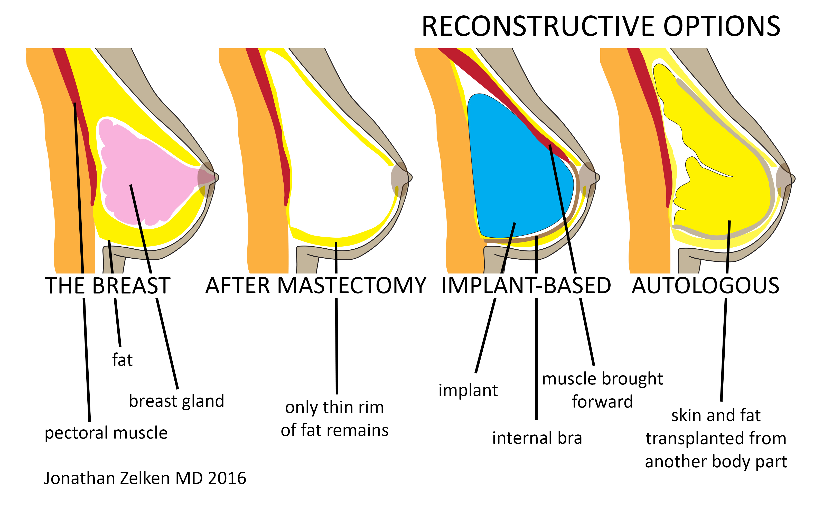

1. Elect not to have reconstruction.
In the United States the vast majority of women elect to undergo reconstruction. Some of our patients elect not to undergo reconstruction. In some cases these patients elect to have delayed reconstruction months to years after their mastectomy surgery. In other cases, the plastic surgeon may decide that the patient is not a safe candidate for immediate reconstruction. Active smokers, morbidly obese patients and poorly controlled diabetics are typically not offered immediate reconstruction due to the higher rate of complications for these patients.

2. Two-Stage Implant Reconstruction
Worldwide, implant-based reconstruction is the most common reconstructive option after mastectomy. There are typically two steps to this surgery. During the first surgery, a tissue expander is placed under the skin and muscle. Think of the tissue expander as a deflated implant that we use to stretch your tissue out. Over time, this creates a pocket that will accommodate the permanent breast implant that will be placed during the second surgery. To hold the tissue expander in place, a soft tissue sling (“acellular dermal matrix”) may be placed between the pectoralis muscle and the bottom of the breast to act like an internal bra.
After your expanders are placed, fluid is injected through a self-sealing port that is integrated into the body of the implant. The process of expansion begins in the operating room. A small needle is passed through the skin and into the port. Saline (the same fluid in an IV bag) is then injected into the expander. The volume that the surgeon is able to achieve during this initial expansion in the operating room will depend on how healthy the skin looks following the mastectomy. The better the skin looks in the operating room, the more fluid the surgeon will place. In most cases, expansion is possible the day of surgery, with some patients getting up to 1/3 of their goal volume. During the first 2-3 weeks following surgery no expansion will occur so that your skin has a chance to recover. When the skin is ready, expansion will resume in our office. Every week or two, more saline is injected into the expander until you reach your desired breast size. This can be the same size, smaller or larger than your current breast size. The expansion takes only a few minutes and for most patients there is minimal discomfort.
The second step in expander reconstruction involves removing the expander and replacing it with a permanent implant. This typically occurs 2-3 months after the final expansion. The second surgery is typically performed on an outpatient basis. Patients have less discomfort than they experience with the first surgery and recovery more quickly

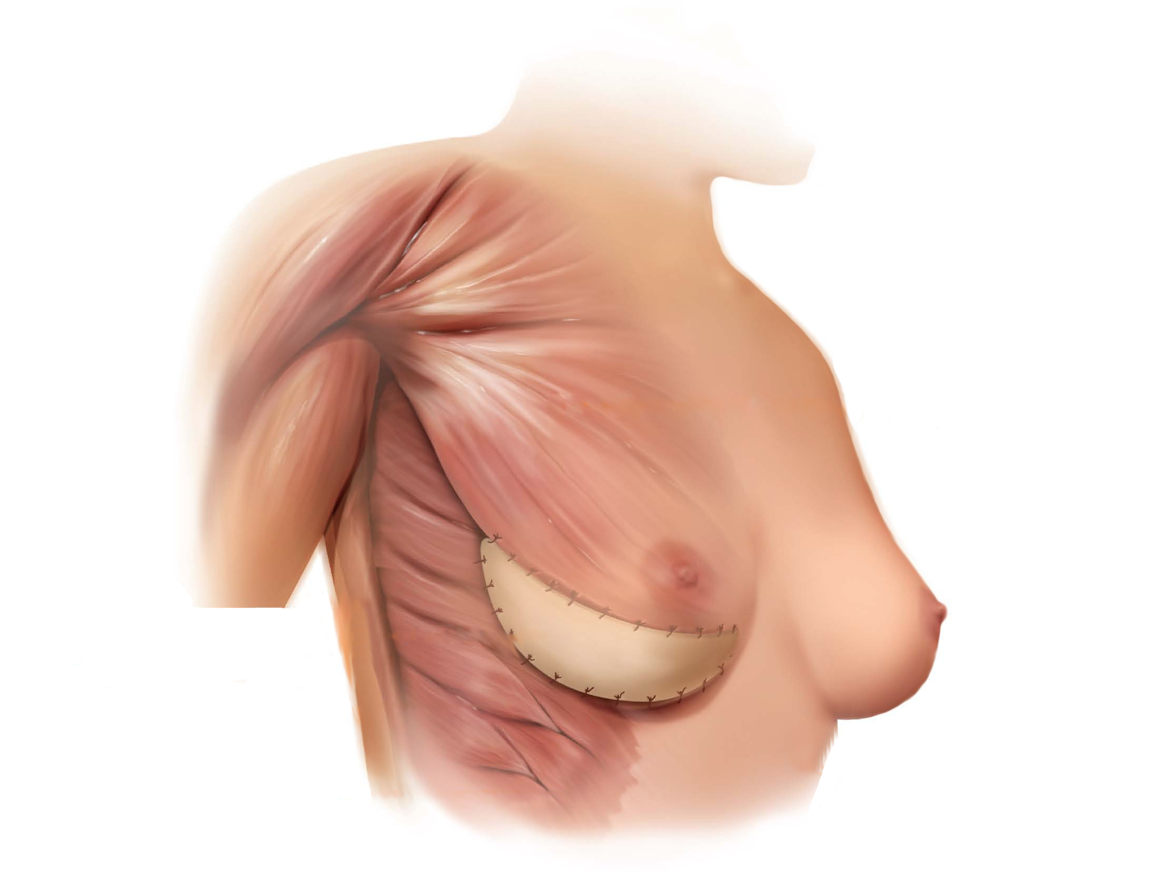
Implant-based breast reconstruction

3. Direct-to-Implant reconstruction
In some circumstances, the surgeon may be able to perform implant reconstruction in one step without the use of a tissue expander. Although this might sound ideal, not all patients are candidates. Healthy women with small breasts who want to stay the same cup size or go smaller may be candidates. Even if you are a candidate, the plastic surgeon may still decide to place expanders in the operating room if there is concern about the blood supply to the breast skin. Because the blood supply to the skin is significantly compromised during a mastectomy, excess tension on the skin immediately after the mastectomy may cause skin to die resulting in exposure of the implant. This may require additional surgical procedures such as removal of the implant or a complex flap reconstruction.

4. Autologous breast reconstruction/flap surgery
With autologous breast reconstruction, tissue is taken from one body part and transferred to the breasts. The most flaps that we use most commonly for breast reconstruction are made using tissue from the abdomen and back.

A. The back – Latissimus Flap
The latissimus dorsi is a large triangular muscle that covers most of your back. This muscle is one of several that help extend the shoulder backwards. Although it is large, its absence does not significantly impact the lives of patients who elect to use this muscle to reconstruct their breasts. With this procedure, the muscle and an overlying ellipse of skin and fat are elevated, leaving only the blood supply attached. The "flap" of skin, fat and muscle is passed through a tunnel to the chest, replacing skin and contributing some volume. In most patients, the flap volume is small so an implant is placed to achieve the volume that the patient desires. The procedure is generally well-tolerated and patient satisfaction is high. Patients typically stay in the hospital 1-2 nights and take 4-6 weeks off work to recover. Patients can usually return to their full level of physical activity even in cases where both sides are used.
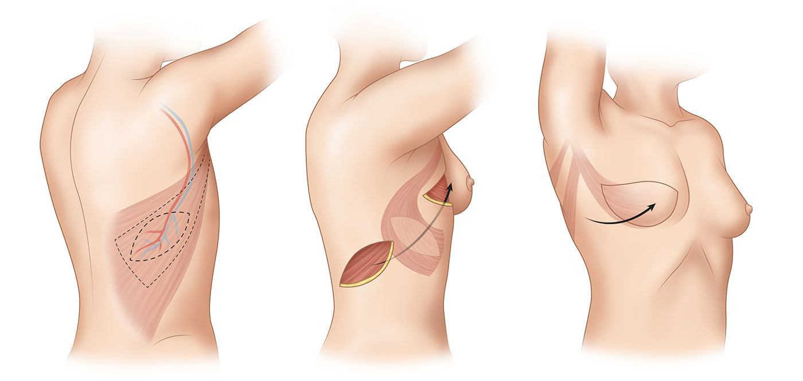
Latissimus dorsi flap

B. The Abdomen –TRAM Flap
This procedure is ideally suited for patients who are good candidates for a tummy tuck procedure, or those who have large breasts or are overweight. This surgery can take up to 4 hours for one side, and up to 6-7 to reconstruct both breasts. Patients usually stay in the hospital 3-5 days, and typically require 6 or more weeks off of work to recover. There is a possibility of loss of some of the transferred skin and fat if the circulation is inadequate to maintain the whole flap. Total flap is very rare (less than 1%).
This procedure leaves a long scar in the lower abdomen in the same location as a typical C-section scar. The surgery also compromises one or both of the rectus (“six pack”) muscles which results in a decrease in core strength.

C. The Abdomen – DIEP Flap
Like the TRAM flap, this procedure utilizes the skin and fat from the lower abdomen. Unlike the TRAM flap, however, no portion of the rectus abdominis muscle is removed. This operation requires expertise in microvascular surgery as the blood vessels supplying the flap are attached to blood vessels in the breast area. The benefit of the DIEP flap is that the muscles are preserved and therefore core abdominal strength is maintained. Candidates for this operation must have sufficient abdominal skin and fat to reconstruct the size breast they would like to achieve. Your plastic surgeon will be able to determine if you are a candidate.

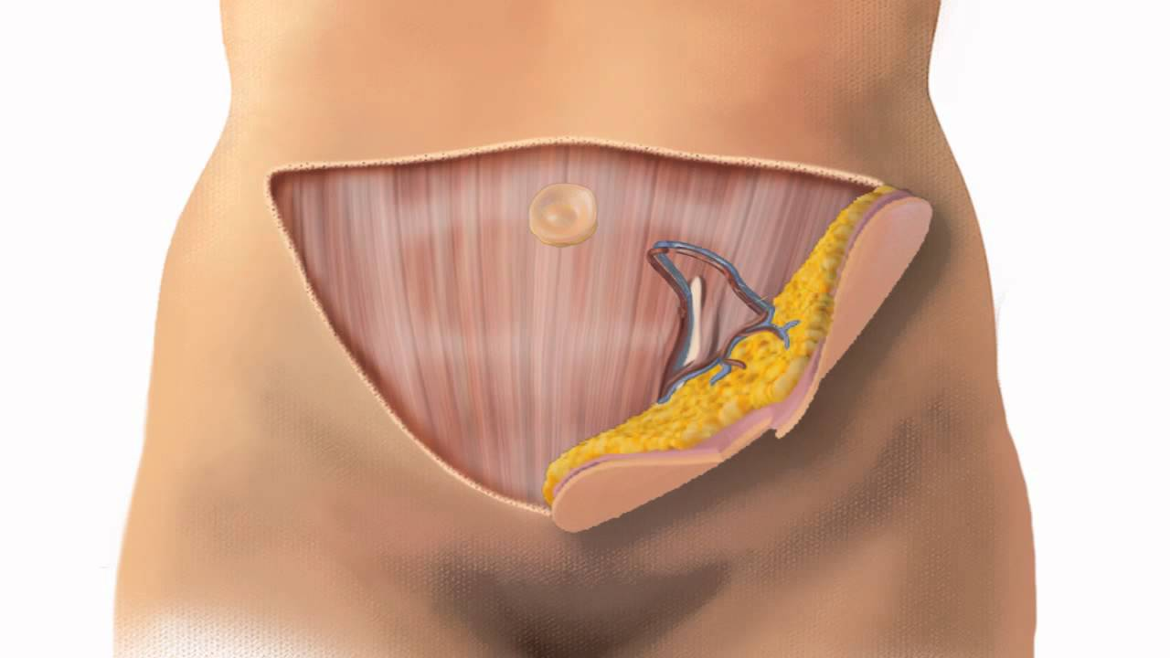
Deep Inferior Epigastric Artery Perforator (DIEP) Flap

D. The Buttocks: SGAP/IGAP flaps
The SGAP and IGAP flap utilize skin and fat from the buttocks. Like the DIEP flap, these flaps remove skin and fat without compromising muscle function. Candidates for the SGAP flap include those patients who are interested in using their own tissues for breast reconstruction, but do not have enough skin and fat in the abdominal area. Other candidates are women who have already had a TRAM or DIEP flap performed on one side and are interested in reconstruction of the opposite breast with their own tissue. The postoperative course is similar to that of the DIEP flap in that approximately 3 days of hospitalization are required for flap monitoring and recovery.

E. Fat Grafting
Fat grafting involves using fat from one part of the body to add volume to another. Using liposuction techniques, fat is collected from the abdomen or thighs,and is then injected into the breasts to correct contour irregularities or to create a more natural transition from the chest to upper pole of the breasts. Fat grafting is performed during the second surgery when the expanders are removed and permanent implants are placed. It may also be performed as part of a revision surgery to correct contour irregularities that develop in the months or years following surgery. Only small volumes of fat are removed during this procedure. The areas where fat is removed may look slightly flatter but patients should not expect the same type of results seen when cosmetic liposuction is performed. Our surgeons frequently combine additional cosmetic liposuction procedures during second stage or revision breast reconstruction for patients interested in body contouring.

Nipple and areola reconstruction
If your nipple is removed as part of your cancer surgery ("skin sparing mastectomy"), you will have the option to have a new one reconstructed for you. This typically occurs 3-4 months after your permanent implants are placed. The procedure takes about 45 minutes, and can be done in the office or the operating room. In this procedure, skin from the reconstructed breast is lifted up and shaped into a nipple that projects up off the breast. Three months after the nipple is reconstructed, we will refer you to a restorative tattoo artist who specializes in breast cancer patients. She will use tattoo techniques to add color to the new nipple and will also create an areola for you. Patients who do not want a nipple that projects can elect to skip the nipple reconstruction and have a tattoo only. With new 3-D tattoo techniques patients can achieve results that look quite impressive.

Revision of Reconstruction
Our goal is to help our patients achieve the best results possible, and to have those results last many years. The statistics show that up to half of all patients who complete reconstruction will have some type of revision surgery performed within 7-10 years to improve the result. These procedures are generally performed on an outpatient basis, and usually involve a shorter recovery time than the initial surgery. Revision reconstruction should be covered by your health insurance plan and is protected by the Women’s Heath and Cancer Rights Act (WHCRA).

Frequently Asked Questions

How long will I be in the hospital?
Lumpectomy with Oncoplastic Reconstruction: Patients go home the day of surgery and follow up in the office 1-3 days after surgery. This appointment will be made for you when your surgery is scheduled.
Mastectomy with Tissue Expander/Implant Reconstruction: Once the postoperative pain is manageable with oral medications you will be able to go home. This can be the same day as surgery or the following day. You will have your first follow up appointment in the office 3-5 days after surgery.
Mastectomy with Flap Reconstruction: Patients will stay in the hospital for 1-2 days following a latissimus flap. After abdominal flaps (TRAMs and DIEPs) patients usually stay 3-5 days.

What problems should I watch for after surgery?
If you are experiencing shortness of breath or chest pain, this may be a sign of a medical emergency and you should call our office or 911 immediatly.
Fever over 101.0F, chills, redness or bruising on the skin that spreads to a progressively larger area, swelling or change in size of one of the breasts, or a sudden increase in drainage. Any of these signs/symptoms should be reported to our office immediately.
You should also call us if you are having pain that is getting worse or is not relieved by the pain medication, or if you are experiencing uncontrolled nausea or vomiting.
If in doubt, call us. There is always a doctor on call, 24 hours a day including weekends.

Medications

What should I expect as far as pain after surgery?
This varies from patient to patient, but most patients report tightness and numbness in the chest, and pain and stiffness at the bottom of the breasts and under the arms. You may experience shooting pains or tingling sensations on the insides of the arms, and it may be difficult to raise your arms over your head or extend your arms fully.
Take the pain medication as prescribed. Many of our patients take it regularly for the first few days, then gradually decrease the frequency and amount of pain medication they use. We often prescribe Percocet as well as Valium. Percocet helps with pain, while Valium helps with muscle spasms and tightness. These medications can be taken together, but not at the same time. Both of these medications can cause sedation, so space them out by at least 30 minutes if you are taking them together, and do not take either of them if you feel drowsy or sedated. Please note that Percocet is a controlled substance and must be filled with the original written prescription. If you need another prescription, it will need to be picked up in person at our office.

What about constipation caused by the pain medications?
This is common with continued use of narcotic pain medication. We advise you to use a stool softener daily until you stop the narcotics. We recommend starting with over the counter colace, twice daily. If constipation occurs, take over the counter dulcolax, 2 tablets at night. If this is not effective, the dose may need to be increased; refer to the package instructions. Drinking plenty of fluids and eating a high fiber diet will also help with constipation, and some patients find prune juice to be helpful. If you go more than 6 days without a bowel movement you may require the use of an enema.

When should I start the antibiotics and how long do I keep taking them?
You should start your antibiotics the evening you get home from surgery and continue them until you are told to stop. Patients who have drains in place will remain on antibiotics unitl they are all removed. If you run out of antibiotics while your drains are still in, you will need to contact our office for a refill. You will be instructed to stop the antibiotics 48 hours after the last drain is removed.

What is the downtime after surgery?
No reconstruction: If we do nothing to reconstruct the breast, you can expect to take a week off work to recover.
Tissue expander reconstruction: Most of our patients take 4-6 weeks off of work to recover. Many of our patients are able to work on a computer from home within a few days of surgery. Patients usually take about two to three weeks before they start feeling back to normal.
Flap surgery: Patients who have flap reconstruction typically stay in the hospital 2-3 days.

Do I need a special bra after surgery?
Patients who are having a mastectomy will be given a prescription for two postoperative camisoles. You can pick these up at the shop in the lobby of the Breastlink center in Orange, Ginny’s at St. Joseph’s cancer center, or at Nordstrom’s. Bring one with you to the hospital to wear home. You will also want to bring an additional loose-fitting layer to wear over the camisole. Please make sure that during the first 2 weeks after surgery all garments worn are loosely fit. Tight clothing may interfere the blood supply to the healing tissues and result in skin loss.
Patients who have a lumpectomy with an oncoplastic procedure will be placed in a bra at the end of the procedure. This garment is provided by the hospital and can be worn for the first several weeks after surgery before you transition back into your own bras.

When will the drains be removed?
This will depend on the amount of fluid that comes out of each drain. You will empty the drains 2 or 3 times a day, recording the fluid out put in milliliters (CCs). You will keep a record of the output that you should bring to each of your appointments. Typically, the drains are removed after 1-3 weeks when the drainage is less than 30 milliliters in a 24 hour period for 2 consecutive days.

How long do I need to use the DVT prophylaxis cuffs?
Use this machine at night when you are sleeping and during the day when you are at rest for approximately 2 weeks after surgery. This machine helps prevent the formation of blood clots. You do not need to bring this machine to the hospital; they will have a similar machine provided for you.

How often will I need to come in to the office after surgery?
You will need to be seen in the office at least once a week initially until the drains are removed and your skin and incisions are healed. Your care team will tell you at each visit when your next appointment should be scheduled. Once your skin and incisions are fully healed your visits will start to become less frequent.

Can I shower after surgery?
Your surgeon will tell you when you may start showering. Depending on the incision dressings and closure, most patients may shower 2 days after surgery. If you have drains we ask that you keep the shower under 5 minutes. The surgical site may get wet brieflyand should be dried thoroughly afterwards with a clean towel. Do NOT use a hairdryer on the surgical site, as your sensation changes after surgery and there is a risk of burning or overheating the skin. Drains should be supported while you shower. You can clip them to a necklace (our office can provide you with a lanyard) or pass the loops through an old belt that you don’t mind getting wet.

When can I take a bath or go swimming?
You will need to wait 8 weeks after the point at which your incisions are fully healed before submerging or soaking the surgical area. This means you will usually need to wait 10-12 weeks after surgery before bathing or swimming. Check with your care team for specific instructions.

What are my limitations after surgery?
You should avoid lifting anything heavier than 5 lbs during the first 3-4 weeks after surgery, so any upper body exercise should be avoided initially. Similarly, avoid any strenuous pushing or pulling movements during this period, such pushing open a heavy door. The range of motion of your arms will probably be limited to some extent, and you should listen to your body and stop any activity or movement that causes pain.
Stretching exercises should be started after all the drains are removed, and these are outlined on a handout you will be given in the office. Be patient with your body as it is healing, and expect slow progress with regaining full range of motion in your arms. If you are having trouble making progress with range of motion or strength, let us know, and we will refer you to physical therapy.

What kind of exercise can I do after surgery?
Walking is encouraged after surgery. You will need to take it easy initially and increase your activity gradually, but walking several times a day helps you regain your strength and energy, as well as being an important prevention strategy for avoiding surgical complications such as blood clots. A good rule of thumb is that if your are sweating, you are doing too much.

When can I start driving?
You should NOT drive while taking pain medications or valium. Once you are no longer taking these medications, you can start driving when you regain sufficient strength and range of motion in your arms. This varies with each patient. Do not drive until you feel your strength and mobility are adequate enough for you to be able to react and turn the steering wheel abruptly in an emergency. Most patients are not able to drive for at least two weeks after surgery.

When can I start taking ibuprofen, asprin, vitamins, and/or fish oil?
These medications and supplements can be resumed after all the drains have been removed.

EXPANSIONS

When will the expansions start, and how often is it done?
We will start adding fluid to the tissue expanders after the incisions and skin are fully healed. This can be as early as 2 weeks after surgery, but may be later. We usually do the expansions at 1-3 week intervals based on patient comfort.

How does expansion work?
We will identify the port in your expander by using a specialized magnet and then place a fine needle through your skin into the tissue expander port. Once the needle is in place a small volume of saline will be injected in to the expander.

Are the expansions painful?
Most patients have numbness in the chest after surgery and do not feel pain at the time of the procedure. Some patients report tightness and discomfort in the chest muscles starting a few hours after the procedure. This may last a few days but will gradually improve as your body adjusts to the expansion. Patients are typically expanded about 50 to 150 cc per visit. Amounts will be determined based on the patient’s comfort level
For pain after expansions, take Valium as prescribed. It is a muscle relant, and it helps with the tightness and discomfort in the chest muscle after the expansion.

How many expansions will I need? How will I know when I’m done?
With each expansion, we will tell you to pay attention to how the new volume feels, and how you fit into your clothing and bras. You will play a large role in determining when the expansions are done.

Will the surgery delay my chemotherapy?
Breast reconstruction should not delay chemotherapy. If patients experience a complication such as delayed wound healing or infection, chemotherapy may be postponed for a short period of time. We work closely with the medical oncologists and will typically "clear you" to start chemotherapy in the time frame they recommend for your cancer treatment.

When will I start radiation therapy?
Patients typically start radiation therapy 2 months after their cancer surgery. Patients who have a mastectomy with expander reconstruction will first need to complete the expansion phase. This is often completed within 2 months of surgery. In some cases the expansion may go on for an additional 2-4 weeks, but this will not influence the cancer treatment. We will communicate with your radiation oncologist to ensure that any brief delay will not impact the success of your radiation therapy.

Next Surgey

What should I expect as far as the next surgery?
For most patients the second surgery happens about 3-5 months after the initial mastectomy. Patients who require postoperative radiation therapy or chemotherapy will have the second surgery delayed until the treatment is complete. The second stage of reconstruction, where the tissue expanders are removed and the implants are placed,is generally an outpatient surgery with a much faster recovery than with the initial mastectomy and reconstruction. You may or may not have drains after the second surgery. Should you have drains, they usually are removed within 5-7 days. Most patients report that there is less pain and “down-time” associated with the second surgery.

How long do breast implants last:
This varies from patient to patient. In our practice we have had patients who have their first implant problem within one year of surgery. We have also cared for patients who have had the same implants for over twenty years. Studies have demonstrated that there is a 93% chance that your implants will still be intact within 10 years of surgery.

What are the different implant choices?
Implants come in various shapes and sizes. We will discuss your goals and work with you to choose the proper fill material, shape, size, and texture of implant for you. Fill options include silicone and saline (salt water). We prefer to use silicone when possible because it tends to result in a more natural feel and appearance.
The term “gummy bear” implants refers to modern form-stable implants that look like a gummy bear when cut (the silicone is firmer and doesn't spill out of the shell). Despite the name, gummy bear implants are not as firm as their namesake candy. We use teardrop-shaped (“anatomic”) and round implants. In reconstructive breast surgery, anatomic implants may look more natural in some women.
Implants come in smooth and textured forms. Most round implants we use are smooth and most anatomic implants are textured. The anatomic implants are textured so they do not spin out of position.

Is silicone safe?
In 1992 the FDA placed a moratorium on the use of silicone implants because of concerns for possible safety issues. Meanwhile, the rest of the world continued to use these implants. In 2006 the FDA met to reconsider the use of silicone implants for both cosmetic and reconstructive surgery. They concluded that the data gathered during this time convincingly demonstrated the safety of silicone. Eight other studies performed worldwide supported the same conclusion.
Today’s silicone implants are far superior to the implants used in the 80’s and 90’s. The silicone used is similar to the texture of Jell-O. Because of this, silicone is much more likely to stay inside the shell. Even if the implants were to rupture, the silicone is very unlikely to spread beyond your breasts.
For more information about implant rupture please go to our website and find the following blog in our “News” section: What if Silicone Breast Implants Rupture.

